Final Program

9-11 June 2008

 | 
Organized by

Sponsored by
 |  |  |  | 
 |  |  | 

Contents

General Information 4
Badges 4
Best Paper Award 7
Conference Location 4
Conference Proceedings 5
How to get there 4
Internet Connection 6
Meeting Rooms 5
Need Help? 6
Paper Legend 7
Registration 5
Social Event and Lunches 6
Tickets 5

Quick Program Overview 8
Welcome Address 11

Scientific Program 11

Monday, June 9 11
Tuesday, June 10 17
Wednesday, June 11 23

Exhibition 27

Conference Locations 28

Hotels 30

EUROSIS Info 32

General Information
  - Conference Location
The Conference itself is held at

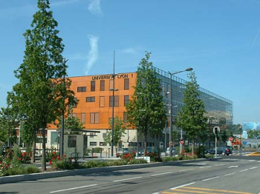 | CESH  Université Claude Bernard Lyon I - Site de Gerland  50, avenue Tony Garnier  F-69366 Lyon cedex 07  Tél.: +33.4.37.28.74.57  Fax: +33.4.37.28.74.58  E-mail : info@cesh.org

We are in building UCBL

The registration desk will be placed in the hallway in front of the meeting rooms on the ground floor. Registration will start on Monday at 8.15 a.m. till 5.00 p.m. On Tuesday it will be from 8.30 a.m. - 5.00 p.m. with Wednesday registration only from 8.45 a.m.- 09.30. a.m.

ALL MAPS ARE AT THE BACK OF THIS PROGRAMME
  - How to get there
By Metro
From Gare de Lyon Part-Dieu there is a direct metro link to the conference site. You need to take BLUE line B south till you come to the end station STADE DE GERAND. This takes about 5 mins from Part Dieu. There is a metro train every 10 mins. It is a five minute walk from the metro station to CESH in the direction of the river.

  - Badges
Each registrant will receive a name badge upon registration. The badge must be worn in order to be admitted to the technical sessions, lunches and social event.

General Information
  - Tickets
Extra tickets for the social event and lunches are available from the registration desk.

Price: (or equivalent in another currency) for extra tickets. All participants will be issued with tickets for lunch and the conference dinner

conference dinner:  lunch | € 60  € 30

  - Registration
The ISC’2008 Registration Desk will be open for information and registration:

Monday, June 9 8.15 a.m. to 5.00 p. m. in the hallway
Tuesday, June 10 8.30 a.m. to 5.00 p. m. in the hallway
Wednesday, June 11 8.45 a.m. to 9.30 a.m. in the hallway

  - Conference Proceedings
Each fully paid registrant will be provided with a copy of the Conference Proceedings (printed format).
(Extra copies are available on a cash and carry basis at special rates during ISC-2008)

Price: (or equivalent in another currency) for an extra copy

ISC'2008 Proceedings | € 50
Other Proceedings –see price list at desk

Other Proceedings can be ordered using the forms available at the conference.

1.7 Meeting Rooms
The meeting rooms will be designated and signposted as ROOM A-B-C at the conference.
Plenary Session: ROOM A
ROOM A for the Keynote Speech, Invited Speakers and sessions
ROOM B for sessions
ROOM C for sessions and back-up sessions
Closing Session: ROOM A
General Information

1.8 Internet Connections
Guest accounts to use the WIFI network have been requested for the duration of the conference. More information will be available at the conference.

1.9 Need Help?
Please see the conference desk for your questions

1.10 Social Events and Lunches
All registrants are invited to
Lunches on Monday and Tuesday and Coffee Breaks will be served in the main hall of the CESH building of the University of Lyon, where you will also find the exhibition and registration desk.

The Conference Dinner
All participants are invited to the conference dinner which, will be held at Maison Villemanzy on the 10th of June from 8.00 p.m. onwards. As we need to give an exact number of participants we would appreciate your con-firmation at the desk before Monday evening. (for those who have as yet not done so) | 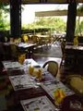

The Conference Visit
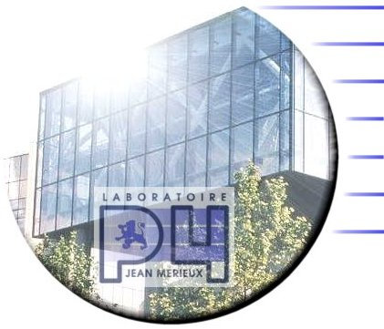 On the afternoon of Tuesday the 10th of June, participants will be taken to visit the to the Laboratory of the Merieux foundation, P4 Labs. 21 av. Tony Garnier, 69007 Lyon The visit is open to EU citizens only and will be on a first come first served basis.

General Information

1.12 Best Paper Award

During the conference the papers, which were accepted as extended papers will be judged by the committee and participants in order to choose the best paper of the ISC'2008 conference.
  - Paper Legend:
Each paper is designated before each paper by it’s number. This number has to be entered on the form for the best paper award

Every Room has an LCD projector and an overhead projector

ALL SESSION CHAIRPERSONS IN THIS PROGRAM ARE PROVISIONAL

THE NUMBERS NEXT TO THE PRESENTATIONS DENOTE THE PAGE-NUMBERS IN THE PROCEEDINGS. IF NO NUMBERS ARE MENTIONED THEN THIS PAPER IS NOT PUBLISHED IN THE PROCEEDINGS

THE AUTHORS WHO ARE UNDERLINED ARE NORMALLY THE PRESENTERS

PAPERS IN GREY BOXES ARE THE EXTENDED PAPERS ELIGIBLE FOR THE BEST PAPER AWARD

CHECK OUT THE OTHER EUROSIS EVENTS ON OUR WEBSITE:
http://www.eurosis.org

MONDAY, 9th JUNE 2008
08.15-17.00 | REGISTRATION
09.00-09.15 | OPENING SESSION IN THE MAIN ROOM –ROOM A
09.15-10.00 | KEYNOTE ADDRESS BY JAY E.ARONSON
10.00-10.30 | COFFEE BREAK
10.30-12.30 | PARALLEL SESSIONS
 | ROOM A | ROOM B | ROOM C
 | DISTRIBUTED  AND  PROCESS  SIMULATION | LARGE  SCHALE  PRODUCTION  SYSTEMS | MEDICAL  SIMULATION
12.30-14.00 | LUNCH BREAK
14.00-15.00 | PARALLEL SESSIONS
 | ROOM A | ROOM B | ROOM C
 | SIMULATION  AND  AI  I | MAINTENANCE  AND  PERFORMANCE  SIMULATION | INVITED  SPEAKER  KHALED GHEDIRA
15.00-15.30 | COFFEE BREAK
15.30-18.00 | PARALLEL SESSIONS
 | ROOM A | ROOM B | ROOM C
 | SIMULATION  AND  AI  II | AUTOMOTIVE  ENGINEERING | SIMULATION  IN  ENERGY

FREE EVENING

TUESDAY, 10th JUNE 2008
08.30-17.00 | REGISTRATION
09.00-10.00 | PARALLEL SESSIONS
 | ROOM A | ROOM B | ROOM C
 | INVITED  SPEAKER  ALAIN CARDON | RFID  SIMULATION | BACK-UP  SESSION
10.00-10.30 | COFFEE BREAK
10.30-12.30 | PARALLEL SESSIONS
10.30-12.30 | ROOM A | ROOM B | ROOM C
10.30-12.30 | COMMUNICATION  SYSTEMS | MULTI-PRODUCT  COSTUMER  DEMAND | PRODUCT  PRESENTATION
12.30-14.00 | LUNCH BREAK
14.00-15.00 | PARALLEL SESSIONS
14.00-15.00 | ROOM A | ROOM B | ROOM C
14.00-15.00 | P4  PRESENTATION | TUTORIAL | MODELLING  AND  SIMULATION  OF TEXTILE PROCESSES
15.00-15.30 | COFFEE BREAK
15.30-18.00 | PARALLEL SESSIONS
15.30-18.00 | ROOM A | ROOM B | ROOM C
15.30-18.00 | SIMULATION  IN  ROBOTICS | SUPPLY  CHAIN  LOGISTICS SIMULATION | APPAREL INDUSTRY  AND  CLOTHING MODELLING  AND SIMULATION
20.00 – 23.00 | CONFERENCE DINNER

WEDNESDAY, 11th JUNE 2008
08.45-09.30 | REGISTRATION
09.00 10.00 | PARALLEL SESSIONS
 | ROOM A | ROOM B | ROOM C
 | MEDICAL  ROBOTICS | LIFTING  AND  STACKING | BACK-UP  SESSION
10.00-10.30 | COFFEE BREAK
10.30 12.30 | PARALLEL SESSIONS
 | ROOM A | ROOM B | ROOM C
 | COMPLEX  ENVIRONMENTS  SIMULATION | HOSPITAL  LOGISTICS | EUROSIS UPDATES  AND  ANNOUNCEMENTS
12.30-12.45 | CLOSING SESSION AND BEST PAPER AWARD

Monday, 9th June 2008

HALLWAY
Registration
08.15 - 17.00

MAIN HALL
09.00 – 10.00
Opening ISC2008 and Welcome
Welcome Address
Christian Vermeulin
Ville de Villeurbanne

Joel Colloc and Claude Petit
CESH- Université de Lyon
ISC'2008 Chairs

09.15 – 10.00
KEYNOTE SPEECH
Chair: Joel Colloc, CESH, Université de Lyon, Lyon, France

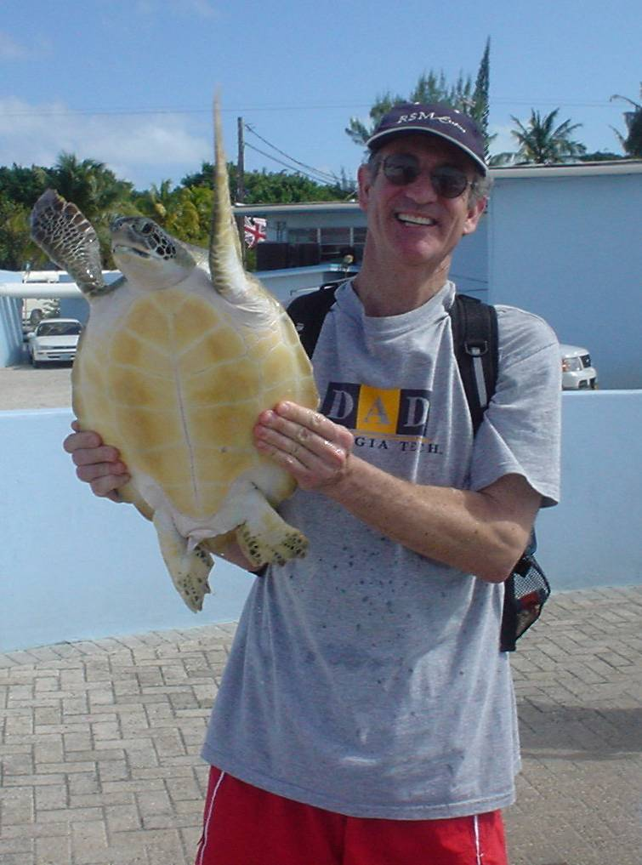

Moving Simulation into Mainstream Business Strategies
Jay E. Aronson

Monday, 9th June 2008
10.00 - 10.30
COFFEE BREAK

10.30 – 12.30
ROOM A- 10.30-12.30 METH
DISTRIBUTED AND PROCESS SIMULATION
Chair: Janos Sebestyen Janosy, KFKI, Budapest, Hungary

METH_02
Pipelined Parallelism Scheduling in homogeneous and heterogeneous
environments
Carmen Odubasteanu and Cãlin Munteanu 47

METH_08
An efficient method for Distributed Constraint Satisfaction Problems
resolution
Kais Ben Salah and Khaled Ghedira 52

MANUF_04
Implementation of the Process Interaction Approach in a General
Purpose Language
Hans P.M. Veeke, Jaap A. Ottjes and Gabriël Lodewijks 65

METH_07
Multiple-model Design and Switching Solution for Nonlinear Processes Control
Ciprian Lupu, Dumitru Popescu, Catalin Petrescu, Alexandru Ticlea, Bogdan Irimia, Catalin Dimon and Andreea Udrea 71

ROOM B- 10.30-11.30 MANUF
LARGE SCALE PRODUCTION SYSTEMS
Chair: Jaroslav Sklenar, University of Malta, Msida, Malta

MANUF_01
The Operational Strategies in focused Flexible Manufacturing Systems
F. Nucci and A. Grieco 81

Monday, 9th June 2008

MANUF_08
Validation of the design of a new steelmaking factory
Nicolas Pipard and Steve Thornton 89

ROOM C- 10.30-12.30 COMPLEX
MEDICAL SIMULATION
Chair: Claude Petit, CESH, Université de Lyon, Lyon, France
N_02
Case-based Reasoning: A Perspective for Pharmaceutical Decision Making
Claude Dussart, François-Xavier Magaud, Joel Colloc and Claude Petit 343

COMPLEX_02
Pregnancy-birth course in Veneto Region: development of a flexible simulation model for description and forecasting
Alessia Barella, Paola Facchin and Giorgio Romanin-Jacur 348

N_03
Kinematic Modelisation of Joint Displacement: Validation in Human Pointing Tasks
Clément Villars, Jérôme Bastien, Karine Monteil and Pierre Legreneur 353

Presentation of CESH
12.30 - 14.00
LUNCH BREAK

14.00 – 15.00
ROOM A- 14.00-15.00 METH
SIMULATION AND AI I
Chair: Alain Cardon

METH_11
A Genetic Algorithm method for generating efficiency intervals in DEA with Imprecise data
Said Al-Gattoufi 17

Monday, 9th June 2008

METH_13
Of the Stability of Closed Self-Organizing Maps (gSOMs) for Predictive Control
Matthias Reuter 25

ROOM B- 14.00-15.00 MANUF
MAINTENANCE PERFORMANCE SIMULATION
Chair: Claude Dussart, CESH, Universite de Lyon, France

COMPLEX_06
Availability Modelling for Optimizing the Complex Systems Maintenance
Radhouane Djeridi, Mathieu Glade, Samir Ghelam, Frédéric Matheron
and Aline Cauvin 255

METH_01
Evaluation of Maintenance Schedule of a Light Metal Industry Plant using Petri Nets
Vrassidas Leopoulos, Charalampos Tsogkas, Evaggelos Champilomatis and Leonidas Tsikonis 104

ROOM C- 14.00-15.00 INV
INVITED SPEAKER
Chair: Joel Colloc, CESH, Université de Lyon, France

A family of Distributed Double Guided Genetic Algorithms for Maximal Constraint Satisfaction Problems
Khaled Ghédira

15.00 - 15.30
COFFEE BREAK

Monday, 9th June 2008

15.30 - 18.00
ROOM A- 15.30-17.30 METH
SIMULATION AND AI II
Chair: Alain Cardon

METH_14
Integrating Immunity features in a Multi Agent Model
Saber Darmoul, Sonia Hajri-Gabouj and Henri Pierreval 31

ANA_02
Project Plant formalization and modeling via typed CPN
Sarka Kvetonova and Dusan Kolar 34

ELEC_01
Identification of Multivariable NARMA Models Using Artificial Neural Networks
Brahim Tlili, Faouzi Bouani and Mekki Ksouri 40

MIL_01
Formation Preserving Navigation of Agent Teams in 3-D Terrains
Ali Galip Bayrak and Faruk Polat 148

ROOM B- 15.30-18.00 MANUF
AUTOMOTIVE ENGINEERING
Chair: Jay Aronson, University of Georgia, Athens, USA

AUTO_02
Sheet Hydroforming of Automotive B Pillar and Coefficient of Friction Effects Analysis
Javad Marzbanrad and Mir Javad Peyman 111

AUTO_01
A new Approach for Modeling of Spot Welds for Numerical Analysis
Abolfazl Masoumi and Amir Najibi 117
Monday, 9th June 2008

ENGIN_04_AUTO
Cutting Simulation Software for Mold Industry
Su-Jin Kim 122

AUTO_03
Simulation and Performance Improvement Process at Ford Powertrain Operations
Habtom Mebrahtu and John Ladbrook 126

ENGIN_07_AUTO
Hybrid Powertrain Simulation
Valerian Croitorescu, Andrei Maciac, Mircea Oprean, Alexandru Marin and Cristian Andreescu 133

ROOM C- 15.30-17.30 ENERG
SIMULATION IN ENERGY
Chair: Izabella Lokshina, SUNY Oneonta, USA

ENERG_01
Protection System Refurbishment at Paks Nuclear Power Plant using Full-scope Simulator
János Sebestyén Jánosy 209

ENERG_04
New application fields of nuclear power plant simulator
MyeongSoo Lee, JinHyuk Hong, SeungHo Lee, JeongKwan Suh and DoHyun Hwang 215

ENERG_05
Optimisation System for a Cogenerative Power Plant
Florin Hartescu and Ion Miciu 219

ENERG_06
Modelling and Simulation of Fluid Power Systems in an Intelligent Programming Environment
Gunnar Grossschmidt and Mait Harf 224

FREE EVENING
Tuesday, 10th June 2008
HALLWAY
Registration
08.30 - 17.00

09.00 – 10.00
ROOM A- 09.00-10.00 INV
INVITED SPEAKER
Chair: Joel Colloc, CESH, Université de Lyon, Lyon, France

To model a system generating Artificial Consciousness Facts: A deep problem
Alain Cardon

ROOM B- 09.00-10.00 LOGIS
RFID SIMULATION/TUTORIAL
Chair: Hans Veeke, Delft University of Technology, The Netherlands

RFID_01
Decision Support System for RFID
Gabriël Lodewijks, Adriana M. López De La Cruz and Hans P.M. Veeke 313

RFID_02
Performance Measurement of RFID
Adriana M. López De La Cruz, Hans P.M. Veeke and Gabriel Lodewijks 317

ROOM C- 09.00-10.00 BACK-UP
This session is for participants, who are unable to present their paper in the allocated slot due to unforeseen circumstances. If this happens info on the papers will be posted at the conference desk.

Tuesday, 10th June 2008
10.00 - 10.30
COFFEE BREAK

10.30 - 12.30
ROOM A- 10.30-12.00 COMM
COMMUNICATIONS SYSTEMS
Chair: Claude Dussart, CESH, Université de Lyon, Lyon, France

METH_03
Expansion of OPNET Modeler's SIP Model for Performance Evaluation of Hierarchical Call Routing in NGN
Hajar Atrianfar, Zohreh Ayatollahi and Mohsen Sepasi 189

ELEC_04
Implementation of Decision Support Systems for Communication Systems
Calin Munteanu, Simona Caramihai, Carmen Odubasteanu and Florian Antonescu 194

COMPLEX_01
Modeling and Simulation of Traffic with Compression at Media Gateways for Next Generation Networks
Dimitar Radev and Izabella Lokshina 199

ROOM B- 10.30-12.30 LOGIS
MULTI-PRODUCT CUSTOMER DEMAND
Chair: Jeff Joines, North Carolina State University, Raleigh, USA

LOGIS_06
Fuzzy Simulation Optimization Approach for the Transshipment Problem with Uncertain Customer Demands
Mohamed Hmiden, Lamjed Ben Said and Khaled Ghedira 235

COMPLEX_08
An Overview of Multilevel and Hierarchical Methods for Discrete Event Simulation of Complex Systems
Esra E. Aleisa 249
Tuesday, 10th June 2008

COMPLEX_04
Modelling and Simulation Features for Products Services
Rinaldo C. Michelini and Roberto P. Razzoli 256

MANUF_07
Evaluating the Impact of the Lean Approach on a Food Processing Line
Flavio Tonelli, Roberto Revetria and Ernesto Revello 93

ROOM C- 10.30-12.30 PROD
PRODUCT PRESENTATION
Chair: to be announced

This session is open to the exhibitors for product presentations
12.30 - 14.00
LUNCH BREAK

14.00 - 15.00
ROOM A- 14.00-15.00 P4
P4 PRESENTATION AND VISIT

Dr. Raoul, director of the P4 Laboratory will give a one-hour presentation about the work they do followed by a guided tour for those participants which are interested in the laboratory
This tour, however, is limited to EU citizens only. To take part you will need to pre-register, providing your full name and address and you will need to have your ID or Passport with you. This will be on a first come first served basis.

ROOM B- 14.00-15.00 TUT
TUTORIAL
Chair: Rinaldo Michelini, University of Genova, Genova, Italy

Humanitarian Demining: Efficiency by Intelligent Planning and Low-Cost Robotics
Rinaldo C. Michelini, Roberto P. Razzoli and Udayanga M. Hemapala 5

Tuesday, 10th June 2008

ROOM C- 14.00-15.00 TEX
MODELLING AND SIMULATION OF TEXTILE PROCESSES
Chair: Vladan Koncar, ENSAIT, Roubaix, France

TEX_09
Modelling and simulation of an active anti-ulcer mattress system
Jalloul Elfehri, François Boussu and Vladan Koncar 387

TEX_08
Modeling the Fiber Yarn Interface for Clothing Design
Ionut Neagu, Pascal Bruniaux, Xavier Legrand and Dorin Avram 393

15.00 - 15.30
COFFEE BREAK

15.30 – 18.00
ROOM A- 15.30-17.30 ROBOT
COMPONENTS SIMULATION, NAVIGATION SYSTEMS AND MOVEMENT
Chair: Rinaldo Michelini, University of Genova, Genova, Italy

ROB_04
A Simulation-based Method for Fault Diagnosis in Hydraulic Components
C. Angeli and A. Chatzinikolaou 143

ROB_02
Fusion of INS with GNSS and its application to Mobile Robot Navigation
L. Domenech, L. Armesto and J. Tornero 156

ROB_05
Trajectory Planning Based on Robot Dynamics with Artificial Potential Fields
José A. Bernabé, Marta C. Mora, Ana Ruescas and Josep Tornero 161

ROB_06
Implementation of the Symbolic Simplification for the Calculation of Accelerations of Multibodies
Dmitry Vlasenko and Roland Kasper 166
Tuesday, 10th June 2008

ROOM A- 15.30-18.00 LOGIS
SUPPLY CHAIN LOGISTICS SIMULATION
Chair: Khaled Ghedira, SOIE, La Manouba, Tunisia

LOGIS_17
Using Simulation to support sustainable Logistical Decision Making in Complex Supply Chains
P.J. Byrne, Paul Ryan and Cathal Heavey 265

LOGIS_16
A Conceptual Model for SME Mechatronics Supply Chain
Jihene Tounsi, Julien Boissière and Georges Habchi 273

LOGIS_05
TRANSSIM Node- A Simulation Tool for Logistics Nodes
Larissa Neumann and Simon Deymann 283

LOGIS_11
A Design Approach for Asset Supply Logistics
Sebastiaan A. Röben, Arnold van den Dool, Jaap A. Ottjes and Gabriël Lodewijks 288

LOGIS_07
Using Container Call Time Information for Restacking Reduction
Wing Sum Lee, Jaap A. Ottjes, Hans P.M. Veeke and Joan C. Rijsenbrij 293

ROOM C- 15.30-17.30 TEX
APPAREL INDUSTRY AND CLOTHING MODELLING AND SIMULATION
Chair: Vladan Koncar, ENSAIT, Roubaix, France

TEX_03
Towards a coupled simulation of cloth and soft tissue
Bastian Linneweber and Arnulph Fuhrmann 401

TEX_04
Strategic Analysis of Speed and Flexibility in sourcing Textile Products
Lisa Hartman, Jeffrey A. Joines, K.A. Thoney and Russell E. King 410
Tuesday, 10th June 2008

TEX_07
Modelling the Fabric-Apparel Compatibility using a Specialised Program
Antonela Curteza, Adela Florea and Viorica Scobiola 416

TEX_10
Optimization of the liquor distribution in yarn package dyeing by CFD
Fabiano Scalora, Carlo Beltramo, Marco Vanni, Giorgio Rovero and
Silvio Sicardi 423

CONFERENCE DINNER – 20.00 -23.00

The conference dinner will be held at
Maison Villemanzy 69001 Lyon
Tel : +33 (0)4 72 98 21 21
Fax : +33 (0)4 72 98 21 22
Email: maisonvillemanzy@yahoo.fr

We will meet at 7.30 p.m. at the metro station is Croix-Paquet.(see map at the back) And then walk about 150m to the restaurant. Or you can go straight to the restaurant and meet there at 8.00 p.m.
Wednesday, 11th June 2008
HALLWAY
Registration
08.45 - 09.30

09.00 – 10.00
ROOM A- 09.00-10.00 ROBOT
MEDICAL ROBOTICS
Chair: Josep Tornero, UPV, Valencia, Spain

ROB_03_MANUF
Virtual Prototyping and Multi-Modal Interfaces to test the Control of an Orthosis
Aron Pujana-Arrese, Joseba Landaluze, Jesús Gimeno and Marcos Fernández 173

ROB_09_HOS
Movement Reconstruction in industrial and medical domains based on topological Petri Nets
Markus Koch, Robert Beckelbans and Jürgen Schrage 181

ROOM B- 09.00-10.00 LOGIS
LIFTING AND STACKING
Chair: Jaap Ottjes, Delft University of Technology, The Netherlands

LOGIS_04_ENGIN
Lift System Optimization by Simulation
Jaroslav Sklenar, Michal Touš and Pavel Popela 301

LOGIS_14
Dynamic Control of Animation Schemes for the Efficient 3D Visualization of Material Flow Simulations
Wilhelm Dangelmaier, Benjamin Eikel, Matthias Fischer and
Christoph Laroque 306

ROOM C- 09.00-10.00 BACKUP
This session is for participants, who are unable to present their paper in the allocated slot due to unforeseen circumstances. If this happens info on the papers will be posted at the conference desk.
Wednesday, 11th June 2008
10.00 - 10.30
COFFEE BREAK

10.30 - 12.30
ROOM A- 10.30-12.00 COMPLEX
COMPLEX ENVIRONMENTS SIMULATION
Chair: Joel Colloc, CESH, Université de Lyon, Lyon, France

METH_06
Finite element modelling of Underground Water Flow in low permeability Lands
Abhijeet Kulkarni, Bahareh Kaveh-Baghbaderani and Vahid Nassehi 365

ENGIN_02
Modeling and Simulation of Feedback Seismic Structural Control
Svetla Radeva and Izabella Lokshina 371

ENGIN_01
FORWAVER – A Wavelet-Based Predictor for Non-Stationary Signals
Dan Stefanoiu, Janetta Culita and Florin Ionescu 377

ROOM B- 10.30-12.30 LOGIS
HOSPITAL LOGISTICS
Chair: Hans Veeke, Delft University of Technology, The Netherlands

LOGIS_12
Proposition of a Simulation Tool for a Cooperative Effective ATP Function
Mariem Siala, Khaled Ghédira and Jean-Pierre Campagne 241

LOGIS_02_HOS
Emergency Room Simulation Prototypes for Incident Management Training
Guodong Shao and Charles R. McLean 323

LOGIS_03_HOS
Modelling Causality in Medical Scenarios
Peter F. Summons 328

Wednesday, 11th June 2008

LOGIS_10_HOS
A step of modeling for the design simulation models in the hospital systems: Application to the New Hospital of Estaing
Julie Chauvet, Michel Gourgand and Sophie Rodier 333

ROOM C- 10.30-11.00 EUROSIS
EUROSIS ANNOUNCEMENTS AND UPDATES
Chair: Philippe Geril, EUROSIS-ETI, Ostend, Belgium

Within the framework of EUROSIS the following action points will be discussed
- the new Journal for EUROSIS conference publications (editors et al…)
- new and old projects updates
- website updates in the area of publications, memberships and online information
- European Research integration in EUROSIS conferences
Wednesday, 11th June 2008

ROOM A 12.30 - 12.45 BEST PAPER
CLOSING SESSION AND BEST PAPER AWARD
Chair: Joel Colloc, CESH, Université de Lyon, France

SEE YOU ALL
JUNE 2009
FOR ISC’2009
AT LOUGHBOROUGH UNIVERSITY
IN
LOUGHBOROUGH, UNITED KINGDOM

General Conference Chair:
Diganta Das, Loughborough University
D.B.Das@lboro.ac.uk

Track proposals and tutorial proposals can be sent in by August 15th, 2008 to philippe.geril@eurosis.org

Exhibition

During the conference participants will be able to see the products of

1) AIC Informatique (http://www.aic-informatique.com/) showing their Linux products and applications

2) Université de Lyon
Students of the Université de Lyon will exhibit some simulation software applications


3) Professional Engineering Publications (http://www.pepublishing.com/)
Will exhibit some information about their scientific publications

Conference Site Maps

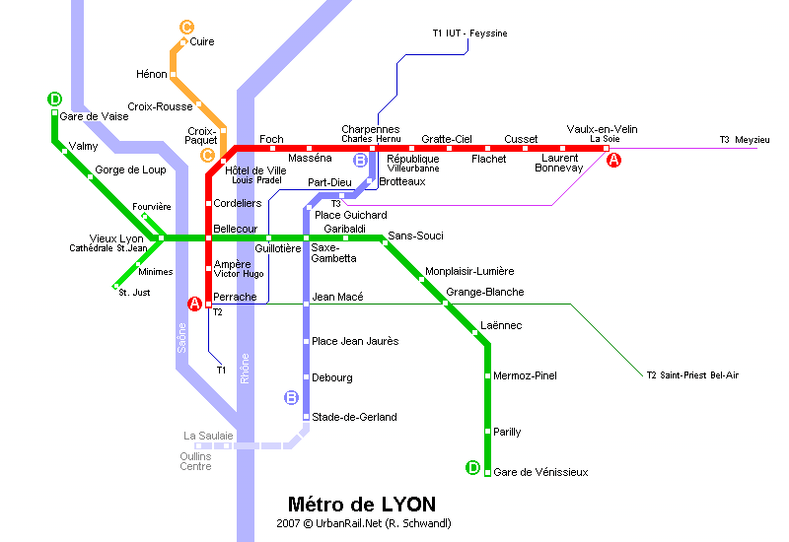

LYON METRO

Conference Site Maps

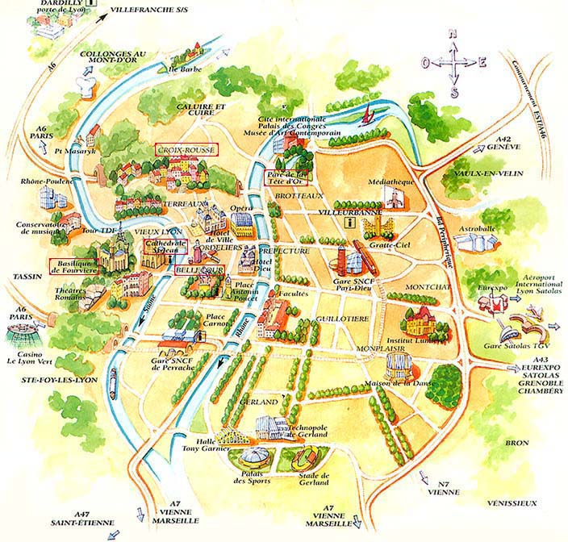

Lyon Centre

Conference Hotels
Please find below a list of hotels in the city centre of Lyon and near the conference site in Gerland.
The Ibis Lyon Centre Perrache**  28 Cours de Verdun Perrache  F-69002 Lyon, France  Tel: +33.4.78375655  Fax: +33.4.78370258 | The Ibis Lyon Part Dieu Les Halles**  78 rue de Bonnel  F-69003 Lyon, France  Tel: +33.4.78629889  Fax: +33.4.78601300
The Hotel Ibis Lyon Gare La Part Dieu**  Place Renaudel  F 69003 Lyon, France  Tel: +33.4.78954211  Fax: +33.4.78604285 | The Ibis Lyon Centre Universite**  51, rue de l'université  F 69007 Lyon France  Tel: +33.4.78727842  Fax: +33.4.78692436
The Hôtel Ibis Lyon Gerland Pont Pasteur  68 Avenue Leclerc Les Berges du Rhone  F 69007 Lyon France  Tel: +33.4.78583070  Fax: +33.4.78722861 | The Novotel Lyon Part Dieu***  47 Bld Marius Vivier Merle  BP 3147  F 69212 Lyon Cedex 03 France  Tel: +33.4.72135151  Fax: +33.4.72135199  E-mail: H0735@accor.com
The Novotel Lyon Gerland***  70 avenue Leclerc  F 69363 Lyon Cedex 07 France  Tel: +33.4.72711111  Fax: +33.4.72711100  E-mail: H0736@accor.com | The Grand Hotel Mercure Chateau Perrache Lyon Centre***  12 cours de Verdun Rambaud  Esplanade de la gare  F 69002 Lyon France  Tel: +33.4.72771500  Fax: +33.4.78370656  Email: H1292@accor.com
The Hotel Hilton Lyon ****  70 Quai charles De Gaulle  F 69463 Lyon, France  Tel: +33.478175050  Fax: +33.478175252 | The Hotel Du Helder Lyon**  38, rue de Marseille  F 69007 Lyon France  Tel: +33.4.78.61.61.61  Fax: +33.4.78.61.61.00  Email: hotelhelder@wanadoo.fr
City Suites Lyon Gerland***.  175 avenue Jean Jaurès  F 69007 Lyon France  Tel: +33.4.37.37.25.25  Fax: +.33.4.78.58.41.57  Email: lyongerland@citysuites.fr | Residence Les Carre Pegase  31, rue Chevreul  F 69007 Lyon France  Tel: 33.4.72.72.08.36

NOTES

EUROSIS was borne out of discussions with the European Community to set up a new kind of Society, which would be project driven instead of driven by pure membership and conferences.

The aim of EUROSIS is to set up topic related Technical Committees which will link directly to European Projects in the field of computer simulation and related areas and to act as a knowledge pool for future European Networks of Excellence, like MOSAIC.

If you would like to receive more information about EUROSIS, please contact

Philippe Geril
EUROSIS-ETI
Greenbridge NV
Wetenschapspark 1
Plassendale 1.
B- 8400 Ostend, Belgium
Tel: +32.59.255.330
Fax: +32.59.255.339
Email: Philippe.Geril@eurosis.org

Please send me info on EUROSIS:
Name:
Address:

Telephone
Fax:
Email:

