Modeling ECG and EEG signals for possible Classification applications

Uvais Qidwai  Associate Professor  Department of Computer Science & Engineering  Qatar University  Email: uqidwai@qu.edu.qa  Mobile: +974 5519 8513 | Mohammed Shakir  Department of Computer Science & Engineering  Qatar University

Abstract

An electrocardiogram (ECG) records the electrical activity of the heart. The heart produces tiny electrical impulses which spread through the heart muscle to make the heart contract. These impulses can be detected by the ECG machine. You may have an ECG to help find the cause of symptoms such as palpitations or chest pain. Small metal electrodes are stuck on to your arms, legs and chest. Wires from the electrodes are connected to the ECG machine. The machine detects and amplifies the electrical impulses that occur at each heartbeat and records them on to a paper or computer. A few heartbeats are recorded from different sets of electrodes. There are normal patterns for each electrode. Various heart disorders produce abnormal patterns. The heart disorders that can be detected include: Abnormal heart rhythms, heart attack (myocardial infarction), an enlarged heart, scarred heart due to a heart attack, etc…

An electroencephalogram (EEG) is a test that measures and records the electrical activity of the brain. Special sensors (electrodes) are attached to the head and hooked by wires to a computer. The computer records the brain's electrical activity on the screen or on paper as wavy lines. Certain conditions, such as seizures, can be seen by the changes in the normal pattern of the brain's electrical activity. Diagnostic applications generally focus on the spectral content of EEG, that is, the type of neural oscillations that can be observed in EEG signals. In neurology, the main diagnostic application of EEG is in the case of epilepsy, as epileptic activity can create clear abnormalities on a standard EEG study. A secondary clinical use of EEG is in the diagnosis of coma, encephalopathies, and brain death. EEG used to be a first-line method for the diagnosis of tumors, stroke and other focal brain disorders, but this use has decreased with the advent of anatomical imaging techniques with high (<1 mm) spatial resolution such as MRI and CT. Despite limited spatial resolution, EEG continues to be a valuable tool for research and diagnosis, especially when millisecond-range temporal resolution (not possible with CT or MRI) is required.

Figure 1 shows typical procedures and signals for both ECG and EEG signals.

(a) | 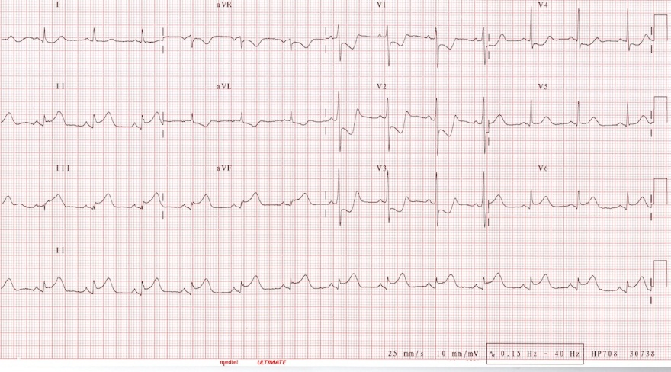  (b)
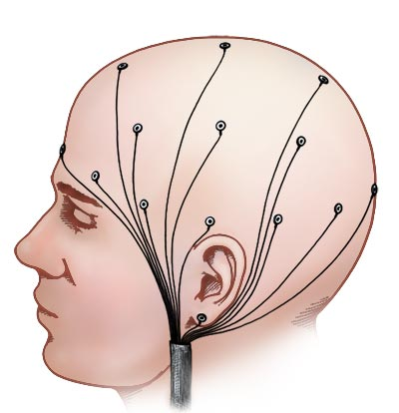  (c) | 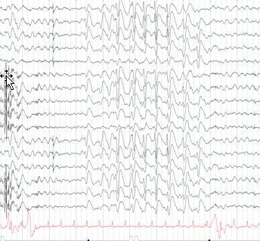  (d)
Figure 2. ECG and EEG probe placements and signals, (a) ECG probe placement, (b) ECG signals, (c) EEG probe placement, and (d) EEG signals.

For a signal processing, mathematical modeling group, both ECG and EEG signals present a wonderful domain of research in model development, activity detection, simulation, and classification. It is a classical area of research where the signal-based or data-driven models can be used for diagnosis and treatment analysis applications. Models describe relationships between measured signals. It is convenient to distinguish between input signals and output signals. The outputs are then partly determined by the inputs. Following figure describes this perspective of data driven model using simple system-identification techniques.

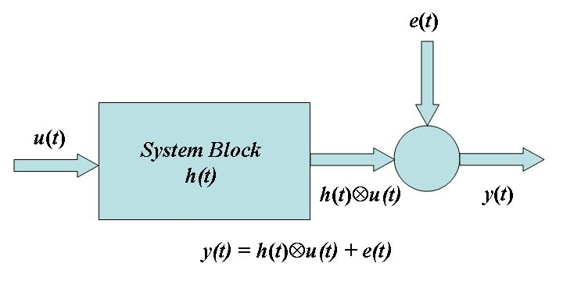

Figure 2: Input Signals u, Output Signals y, and Disturbances e

All these signals are functions of time, and the value of the input at time t will be denoted by u(t). Often, in the identification context, only discrete-time points are considered, since the measurement equipment typically records the signals just at discrete-time instants, often equally spread in time with a sampling interval of T time units. The modeling problem is then to describe how the three signals relate to each other.

In this tutorial, we will explore the applications of the System Identification as well as some of the sophisticated Signal Processing techniques within parametric modeling domain using the real ECG and EEG signals. The main emphasis is on being able to classify various types of patterns present in the signals. Such classifications can be used in medical diagnostic procedures as well as for other multimedia applications. The general outline of the techniques presented can be used with any type of input-output measurement system for model detection and validation applications. This data-driven approach helps you describe systems that are not easily modeled from first principles or specifications, such as chemical processes and engine dynamics. It also helps you simplify detailed first-principle models, such as finite-element models of structures and flight dynamics models, by fitting simpler models to their simulated responses.

Who should attend?

The tutorial is designed around the hands-on presentation of applied mathematical techniques to the ECG and EEG signals. Anyone with keen interest in mathematical modeling, Pattern Recognition, and general Signal Processing etc… can benefit from this tutorial.

Outline of the topics:

- Introduction to ECG and EEG signals.
  - Probes and Simulators.
  - Data Acquisition.
  - Signal characteristics.
- Basics of 1D Parametric modeling.
  - ARMA and Time series models.
  - Hidden Markov Models (HMM)
- Basics of some of the related Signal Processing techniques.
  - Time-Frequency Analysis.
  - Wavelet Analysis.
- Detecting Signatures for certain disease and/or activity using ECG and/or EEG signals.

